# Identify all the different components you know in the following motherboards.

Number 1

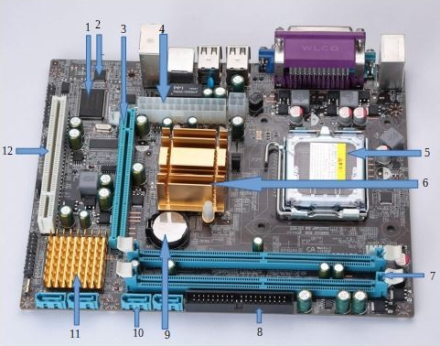

Number 2

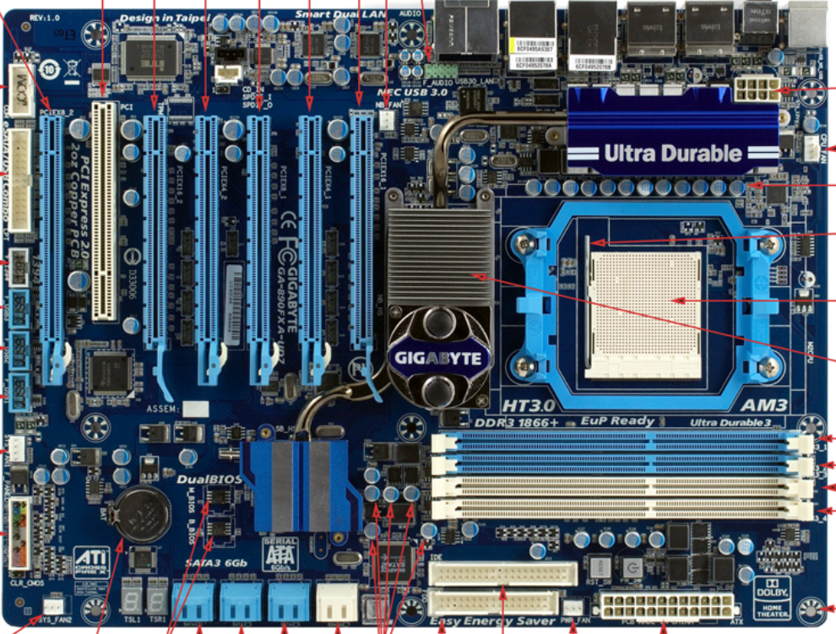

Number 3

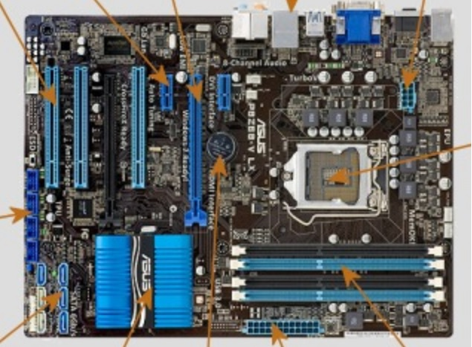

Number 4

Cooler

ATX-8 pins

Socket

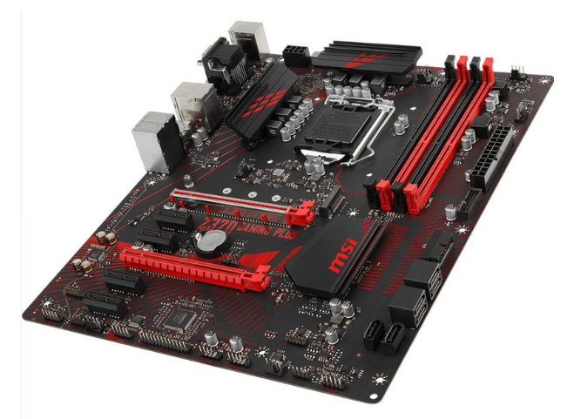

PCH Chipset

ATX

M2

CMOS Batery

PCIE x1

SATA

RAM

Expansion Slots

PCIEx16

Number 5

PCIEx16

Memory SATA

PCIEx1

Socket

PCI

Cmos

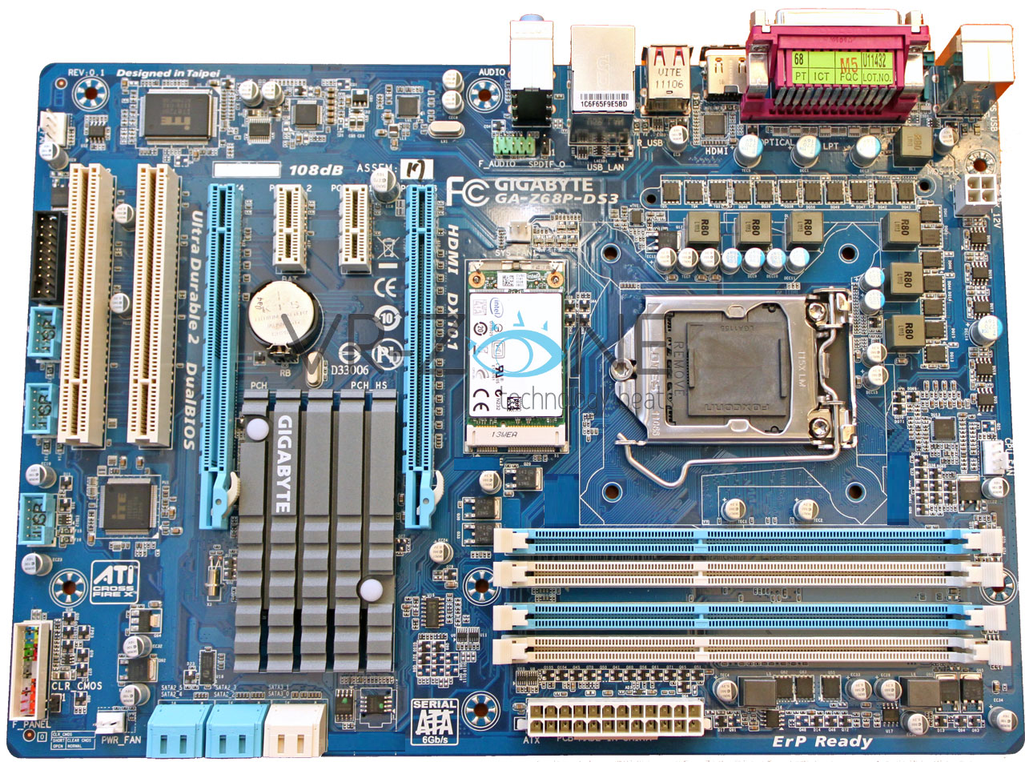

Power Fan

PCH

Dual BIOS

ATX

RAM

Number 6

PCI

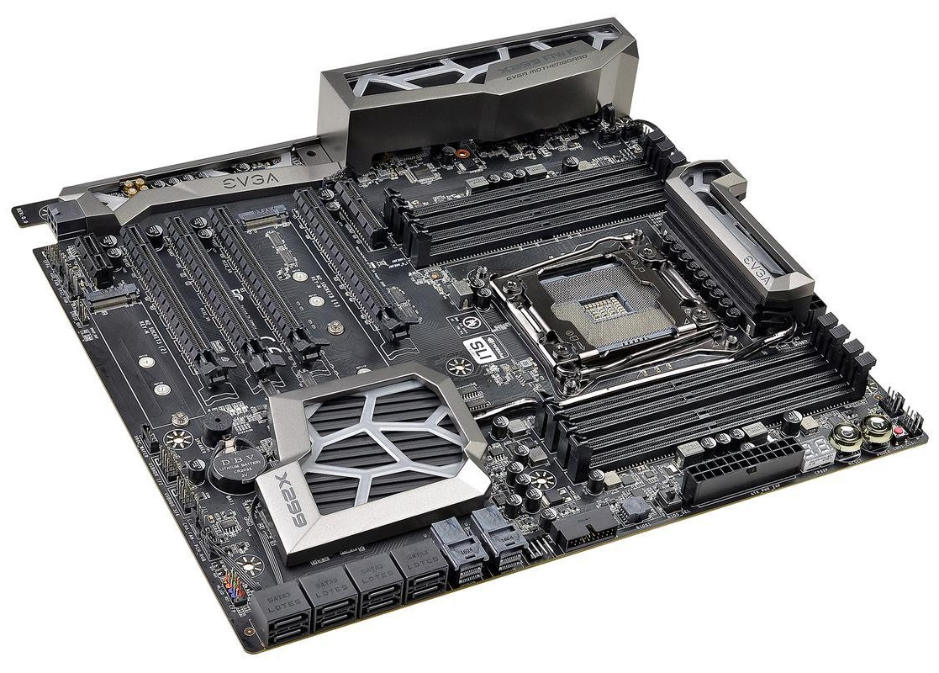

M2

North bridge

ATX

Chipset

CMOS

South bridge

U.2

PCIEx16

RAM

SATA

# Identify the external connectors in the following pictures

Number 1

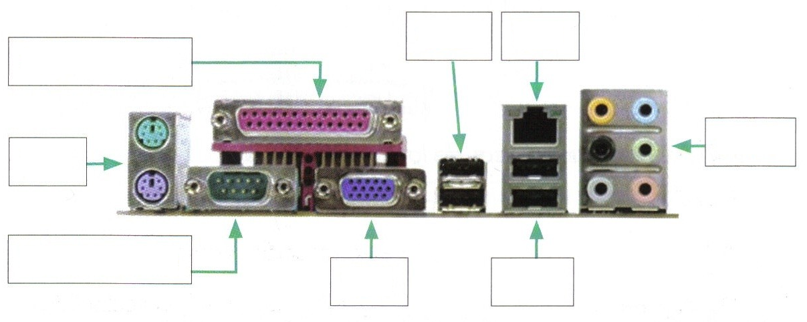

USB 3.0

HD Audio

VGA

Serial

PS/2

LAN

USB

Parrarel Port



Number 2

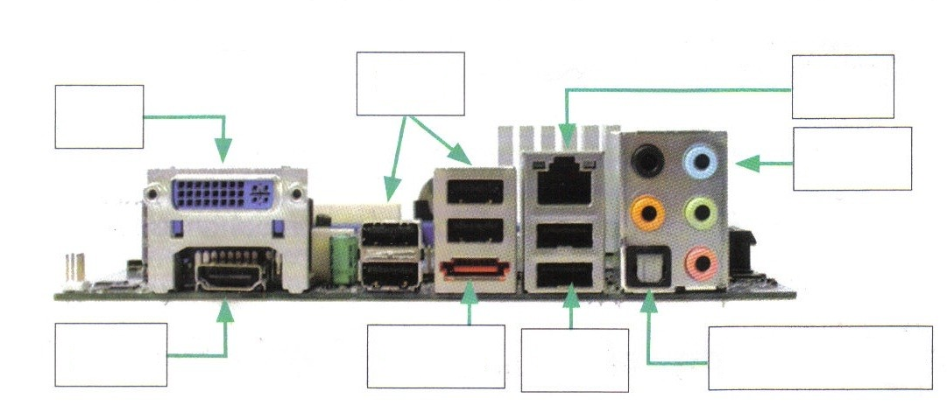

E. SATA

HDMI

USB 2.0

USB 2.0

Optical/Pdif

Audio Connector

LAN

USB

DVI



Number 3

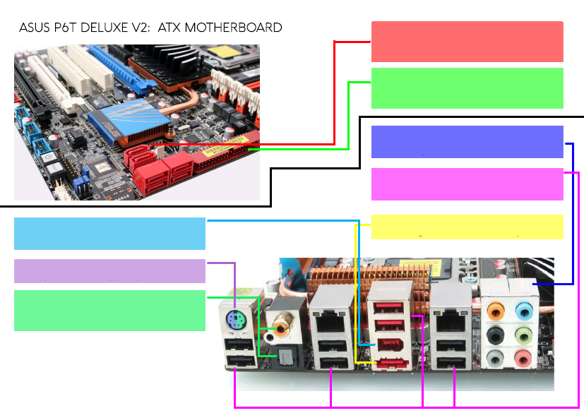

Coaxial

PS/2

FIrewire

External sata port

USB

Audio Jack connector

Ide port

ESATA

Number 4

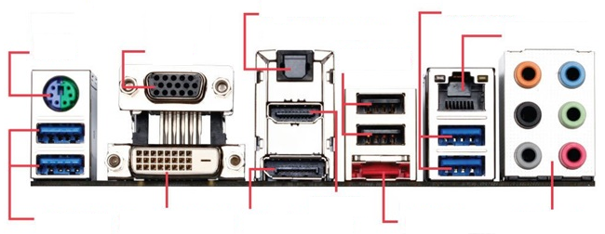

Dual Link DVI

USB 3.0

Display port

HDMI

eSATA

HD Audio

LAN

USB

Optical S/PDIF

VGA

PS/2